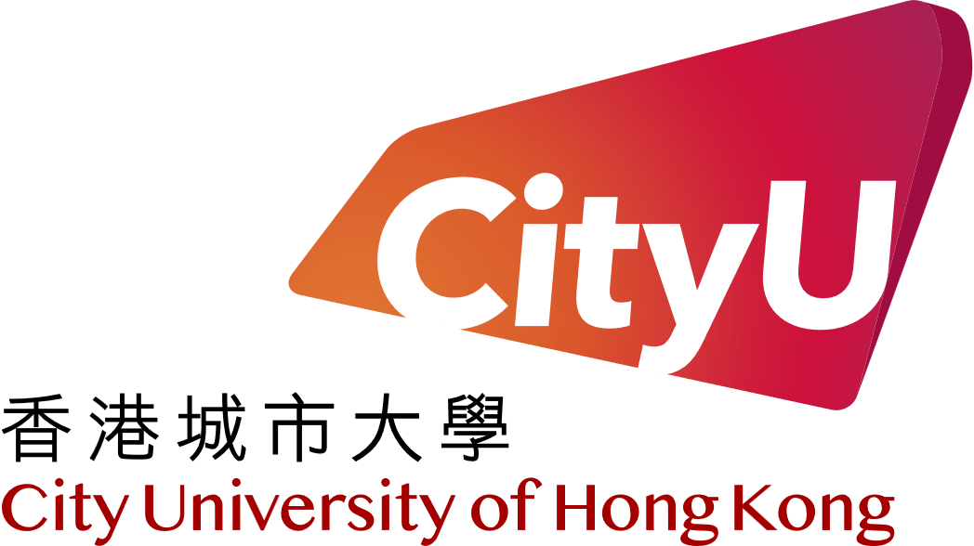

City University of Hong Kong

Department of Computer Science

CS3343 Software Engineering Practice

2024 - 25 Semester A

**CityU Cinema System**

**Self Assessment Report**

**Group 2**

**Name SID**

CHAN Ka Hong 57845658

FUNG Wing Ho 56755919

LAW Lok Hang 57842515

NG Ka Ho 56652261

WONG Tsz Kin 57847086**CHAN Ka Hong (Project Manager)**

I believe this is my very first time working as a team for an open-source software project. As the project manager of the team, I have the overarching responsibility in overseeing the cooperation of my team, the progress of development, as well as ensuring the smooth completion of the entire project on time. And I must say that I am very proud for our team to have successfully delivered a completed project, despite the time constraints, our inexperience, and the obstacles and challenges we encountered along the way.

One of the most valuable experiences I gained as a project manager is learning how to reach a consensus among our differences through effective negotiation and communication. In the beginning, different team members might have their respective opinions and approaches towards a certain problem. This would not have been any issue if it were a solo project as we could all work alone with our own visions and ideas. However, considering that this is a teamwork, we cannot go our separate ways and do whatever we like. We must reach a commonly agreed goal before we can take action. Thus, as the project manager, I never hesitate to initiate meetings with my team so that we can openly and candidly discuss our views and resolve our differences. Mediating a discussion and ensuring that it will not escalate into an unwanted conflict might not be an easy task, but this is something one should go through and master to successfully manage a software development project. And in the end, I am glad that the time and effort we have spent in the numerous meetings we have had throughout this 3-month development journey are not in vain, and instead, they have forged our team a much closer bond for collaboration that has resulted in a pretty satisfactory teamwork and final products.

Management aside, there are also some valuable technical skills acquired. I used not to value much about software testing, for I often deemed it time-consuming and unnecessary. By test running the program a few times and checking if it works as expected, one can easily confirm if the program works or fails. However, with this project, I learnt the essence of doing unit testing. With the codes being accessible, writing unit tests can genuinely ensure and target the executable paths of a piece of code, thus making sure if a certain section of the code can be reached or gets left unused. It is different from black-box testing as testers can pinpoint every part of the code and apply specific remedies if necessary. Despite the extra time spent at first, it may actually save us more effort in the future during software maintenance phase as we have established a solid code foundation since the very beginning. And this kind of practice of writing unit and integration tests will be a necessary skill and habit for me to bear in mind down my software development journey.

**FUNG Wing Ho (Assistant Project Manager)**

That’s the greatest scale school software project with highly organized and comprehensive documents I have ever participated in. As the assistant project manager, I must assist the project manager to overlook the whole progress, while that stuff is mainly handled by the project manager, so I always focus on some potential mistake that might be negligible by him. In addition to group management, I am also responsible for programming the input/output standard structure with exception handling and format checking, user relevant classes, user relevant database features, test cases, demo the system and little paperwork.

For the issues I have encountered, early division of work may be the most memorable one. Since project manager advocate to divide the system by features without an initial design; in my perspective, it might result in problems, or the integration work would be heavy. However, after careful consideration, a complete system design takes time, and the initial design may not reflect the final state. In the end, coordination and integration are still required. The start time of work will be delayed compared to early division of labor by features. Reducing the pressure to integrate or working earlier to gain more time to integrate may counteract mutually. Moreover, in the absence of experience, completing the initial design of the entire system may not be an easy task, and the results cannot be guaranteed. Finally, after a second discussion with the project manager, we reached a consensus that work should be allocated according to system features first.

Overall, through this project, I improved my program proficiency; became familiar with different development tools, such as VSCode, Copilot, GitHub and Visual Paradigm. For the next system development project, I am confident to do better. But still, I do not want to be the project manager who should take over too many things, unless no one is qualified.

**NG Ka Ho (Programmer/Tester)**

In this project, I worked on developing and testing a movie scheduling feature of the whole program. My primary responsibilities included designing the movie scheduling strategies and approach, and writing unit tests using JUnit, implementing system test cases, and ensuring that the functionality met the specified use-case scenarios. This project helped me understand real-world movie ticket system development challenges and apply theoretical concepts in a practical setting.

After this project, I learned the difference between white-box testing and black-box testing, applying each where appropriate. White-box testing helped ensure the correctness of internal logic using JUnit, while black-box testing validated the system’s functionality through use-case scenarios. For modules like the command module and the main function, I learned to design system tests that simulate real-world use-case scenarios to ensure functional correctness. Moreover, debugging became a critical skill as I encountered unexpected errors during unit testing. This taught me to analyse stack traces and identify root causes effectively.

Beside the technical knowledge and skill, I also learnt the time management and teamwork when I am one of the team members of a group. Because balancing the implementation of test cases with debugging and reporting was challenging. I learned to prioritize tasks based on project deadlines and complexity. And working with team members to integrate different modules taught me the value of clear communication and documentation to avoid misunderstandings.

I am also facing some challenge during the project phase, such as hard to understand legacy code sometime cause certain parts of the codebase were written by other team members, and understanding their structure and logic was time-consuming

To sum up, this project was a valuable learning experience that allowed me to apply theoretical concepts to real-world software development challenges. While I faced some difficulties, these challenges eventually helped me grow both technically and personally. By the end of the project, I felt more confident in my ability to design and execute effective testing strategies, collaborate with a team, and address complex problems systematically.

**WONG Tsz Kin (Programmer/Tester)**

In this project, I have learnt a lot and faced some challenges. It is a valuable experience to learn and explore to become better at programming and cooperating.

The first thing I learned from this project is the importance of testing. The project is divided into several parts, each built by one groupmate. Finally, all the codes written are merged using git and GitHub for the final product. However, some parts may not be able to be built completely if they lack other people’s code, so it is hard to run the program and test it directly. Testing is required to solve the problem. By writing test cases, I can know whether the code works without building a complete program to run and test myself. I can write different test cases for different methods and classes. If others have not yet implemented some classes, I can build some stub classes to simulate their behaviour and test if my code works without waiting for others to finish.

Another thing that I learned during the project was to cooperate with others. Although there have been several group projects, this project is the first to form a group and build a system together. It is a memorable experience. By reading others' code, I can learn more about different methods and approaches to build the system and solve the problem. Also, sometimes there are different opinions among different groupmates. They may have thoughts about specific parts of a project that contradict each other. When such a thing happens, we must find a balance between ideas and a solution that can satisfy their needs, which is a valuable experience when cooperating with others.

One of the difficulties I have experienced is understanding other people’s design and implementation of a particular part. Everyone has their thoughts on solving the problem in programming, so sometimes, it is hard to follow and understand some codes written by others. When this happens, I will use the debugger to run the code line by line to see how it works when handling different conditions. Also, reading the class diagram to know the relationship between classes is another great way to understand the code. In most cases, I can understand the code by doing so. If I still cannot understand, I will ask my groupmates to explain the code, and I can learn more about different approaches to the problem from their explanation.

Another challenge for the project is time management. This year, I need to work for a company for placement. I must work from Mondays to Thursdays and return to the university on Fridays. It is tiring after a day of work, and I sometimes do not have enough energy to continue the project. In this situation, time management is essential. I would use my weekends to do the project as much as possible. By doing so, I can rest if I feel too tired after work and do not want to do anything.

In conclusion, I have gained much experience from this project. Although there are different challenges, I can still overcome them and learn more from them. I can use the experience learnt from this project to develop myself.

**LAW Lok Hang (Programmer/Tester)**

Participating in the CityU Cinema System project has been an invaluable experience, providing numerous opportunities to enhance my programming skills and improve my ability to collaborate effectively with others. Throughout this project, I have encountered various challenges and learned important lessons that have contributed to my personal and professional growth.

In this project, my primary responsibility was to implement the admin functions. This involved creating features that allowed administrators to manage the cinema system efficiently. These functions included adding and updating movie listings, managing user accounts, and overseeing booking and payment processes. Developing these features required a deep understanding of the system's architecture and careful attention to detail to ensure that the admin interface was both functional and user-friendly. Balancing my time between an internship and academic responsibilities was one of the most significant challenges I faced. From Monday to Thursday, I was committed to my internship, which left me with limited time to work on the project. Additionally, this project was the largest school assignment I had undertaken, requiring substantial time investment. On top of this, I was also enrolled in two other courses, further complicating my schedule. To manage my time effectively, I had to prioritize tasks and make efficient use of my weekends to work on the project. This experience taught me the importance of time management and the need to balance multiple responsibilities simultaneously. Effective coordination with my teammates was crucial for the success of this project. We used Git for version control, which facilitated collaboration but also presented challenges. Different team members had varying ideas and approaches to solving problems, which sometimes led to conflicts. Thorough discussions were necessary to align our efforts and ensure that everyone was on the same page. This process of negotiation and compromise was essential in developing a cohesive and functional system. It also highlighted the importance of clear communication and teamwork in achieving project goals.

This project provided numerous learning opportunities that have significantly contributed to my development as a programmer and team member. Working on the admin functions allowed me to brush up on my programming skills. I gained hands-on experience with various programming languages and tools, enhancing my ability to write clean, efficient, and maintainable code. This project also provided an opportunity to apply theoretical knowledge to practical problems, deepening my understanding of software development principles.

In conclusion, the CityU Cinema System project has been a transformative experience. Despite the challenges, I was able to overcome them and learn valuable lessons. Implementing the admin functions, managing my time effectively, and collaborating with my teammates have all contributed to my growth as a programmer and team member. The skills and knowledge I gained from this project will undoubtedly be beneficial in my future endeavors, and I am confident that I am better prepared to tackle new challenges and opportunities.